Civil Advisory Council
المجلس الاستشاري الهندسة المدنية

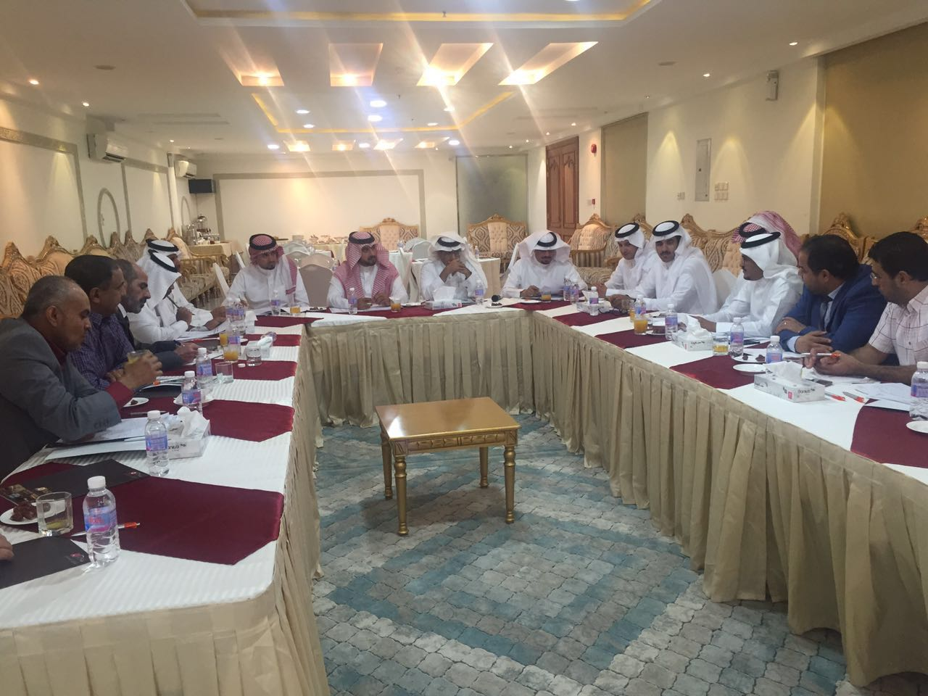

CE Advisory Council
No. | Advisory Council Members
1. | Associate Professor Dr. Abdullah Alwadie  Dean, College of Engineering  Najran University  Najran, Saudi Arabia  Tel: 00966 507776986  Email: asalwadie@nu.edu.sa | 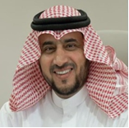
2. | Engineer Hassan Salem Al Juraib  General Manager  University Project department  Najran, Saudi Arabia  Tel: 00966 556663166  Email: hasgr999@hotmail.com | 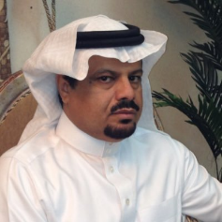

No. | Advisory Council Members
3. | Engineer Erfan Hatem Al Mansoor  Assistant Manager  University Project department  Najran, Saudi Arabia  Tel: 00966 544196000  Email: ehalmansoor@hotmail.com | 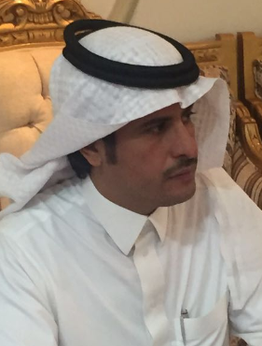
4. | Engineer Raid Faisal Alghadam  Civil and Safety Engineer  University Project department  Najran, Saudi Arabia  Tel: 00966 543311138  Email: ralghadam@hotmail.com | 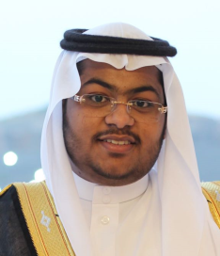
5. | Associate Professor Abdulnoor A.J Ghanim  Civil Engineering Department  College of Engineering  11001 Najran, Saudi Arabia  Email: aaghanim@nu.edu.sa  Tel: 00966 545529898 | 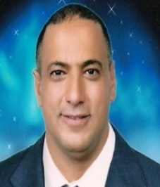
6. | Assist. Prof. Dr. Ibrahim Hakeem  Civil Engineering Department  College of Engineering  11001 Najran, Saudi Arabia  Email: iyhakeem@nu.edu.sa  Tel: 00966 569584746
7. | Assist. Prof. Dr. Saleh Hamel Al-Salem  Civil Engineering Department  College of Engineering  11001 Najran, Saudi Arabia  Email: dr.saleh.uk@gmail.com  Tel: 00966 555 72 4545 | 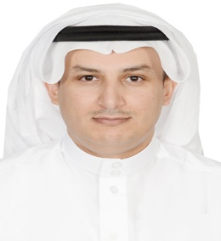
8. | Engineer Ahmad AlShahrani

