College Advisory Council (CAC)
المجلس الاستشاري لكلية الهندسة

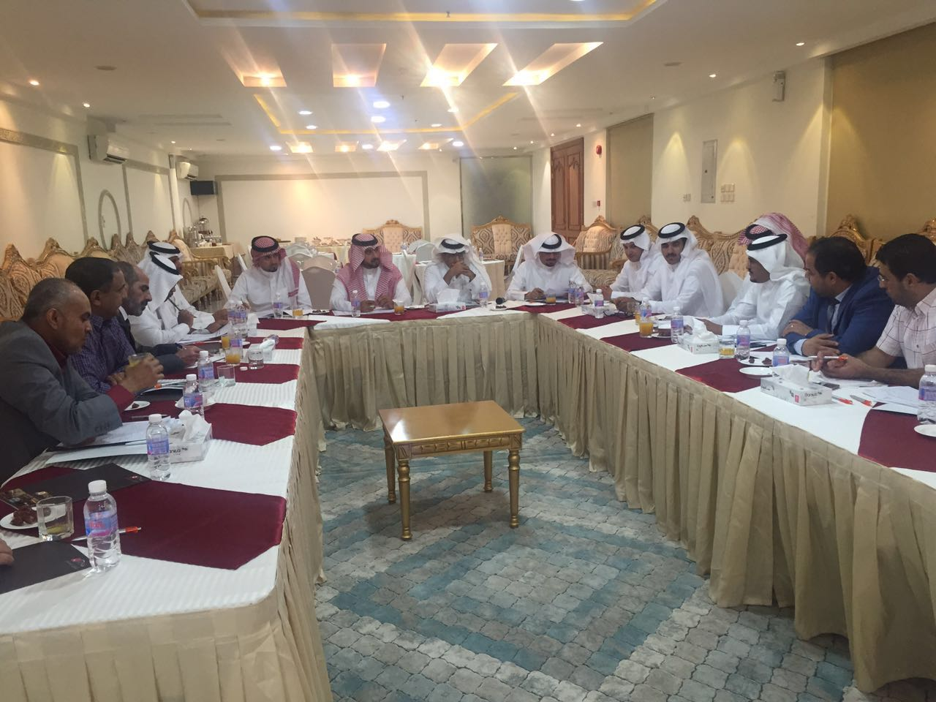

College Advisory Council
No. | Advisory Council Members
1. | Professor Abdullah Alwadie  Dean, College of Engineering  Najran University  Najran, Saudi Arabia  Tel: 00966 507776986  Email: asalwadie@nu.edu.sa
2. | Dr. Hisham Alghamdi  Vice Dean, College of Engineering  Najran University  Najran, Saudi Arabia  Tel: 00966 503790889  Email: haalghamdi@nu.edu.sa
3. | Engineer Hassan Salem Al Juraib  General Manager  University Project department  Najran, Saudi Arabia  Tel: 00966 556663166  Email: hasgr999@hotmail.com

4. | Engineer Erfan Hatem Al Mansoor  Assistant Manager  University Project department  Najran, Saudi Arabia  Tel: 00966 544196000  Email: ehalmansoor@hotmail.com
5. | Engineer Raid Faisal Alghadam  Civil and Safety Engineer  University Project department  Najran, Saudi Arabia  Tel: 00966 543311138  Email: ralghadam@hotmail.com
6. | Associate Professor Abdulnoor A.J Ghanim  Civil Engineering Department  College of Engineering  11001 Najran, Saudi Arabia  Email: aaghanim@nu.edu.sa  Tel: 00966 545529898
7. | Assist. Prof. Dr. Ibrahim Hakeem  Civil Engineering Department  College of Engineering  11001 Najran, Saudi Arabia  Email: iyhakeem@nu.edu.sa  Tel: 00966 569584746
8. | Engineer Saleh G. AlGhamdi  Director of SEC-Najran  Najran, Saudi Arabia  Tel: 00966 530588559  Email: saLdaghish@se.com.sa
9. | Engineer Fawaz Masoud Alhadi  Najran College of Technology  Head of Electrical Technology Department  Najran, Saudi Arabia  Tel: 00966 503724374  Email: falhadi@tvtc.gov.sa
10. | Engineer Ahmad AlShahrani  Engineer

Objective of College Advisory Council (CAC)
The College Advisory Council (CAC) aims at contributing to the continuous improvement of the College's academic programs, guiding its future policies, evaluating its strategic plans and communicating with the public and private sectors.
General Organization of College Advisory Council (CAC):
- The College Advisory Council shall nominate the members of the Council not less than nine members and not more than fifteen members. The composition shall be approved by the Rector of the university.
- The composition of the Council shall be as follows:
  - Dean of the College.
  - Vice Dean for Development and Quality.
  - Members (seven to thirteen) with experience in various business sectors from inside or outside the Kingdom, including some distinguished graduates.
Mode of Functioning for College Advisory Council (CAC)
- The Board shall, at its first meeting, elect the President and Vice-President, provided that he is not the Dean of the College and the Secretary of Development and Quality shall be the Secretary of the College Advisory Council.
- The Board shall meet at the invitation of its President at least twice a year.
- The sessions of the Council may be held inside or outside the college and it may invite any person outside of the Council Committee to attend its meetings.
- Membership of the Council shall be for two years subjected to renewable as required.
- The certificate of appreciation shall be given to the Members of the Board at the end of their term from the Advisory Council.
Duties of the CAC Officers
a) President: It shall be the duty of the President to act as the executive head of the College Advisory Council and to preside over its meetings. The President shall have power to call for meetings of the Council and to set the agenda. The President shall provide appropriate information and data necessary for the Council to carry out its activities and shall inform the members on actions and recommendations of the Council.
b) Vice- President: The Vice- President shall assist the President in the performance of assigned duties and, in the absence of the President, shall assume the power and responsibilities of the President.
c) Secretary: The Secretary shall maintain accurate, action-based minutes of all meetings, distribute minutes to each member on a timely basis, and be responsible for the general communication required for the efficient and effective discharge of the Council’s duties and responsibilities.
Functions of the Advisory Council:
Advisory Council is purely advisory. It is not an administrative, legal or policy making body. Its support for the college and its students involves certain roles and/or responsibilities. The main functions of CAC members are:
- Making proposals on what serves the future of the college.
- Provide ways to deepen partnership between the college and the local and global community.
- Contribute to the development of programs and curricula according to the requirements of the labor market.
- Contribute to the implementation of the strategic plan of the College.
- Provide proposals that should provide material and moral support to the College.
- Contribute to the establishment of a coordination mechanism to establish joint projects between the college and the sectors of society in order to find solutions to the problems of society in an integrated manner.
- To propose methods to provide funding sources for the College's development projects.
- Identifying jobs or entrepreneurial opportunities, through co-op work experiences, internships, apprenticeships, topical summits, or career fair involvement.
- To check the current and future trends affecting the program and then recommending the knowledge, skills and competencies required for successful career entry or re-entry in KSA.

