EE Advisory Council
المجلس الاستشاري قسم الهندسة الكهربائية

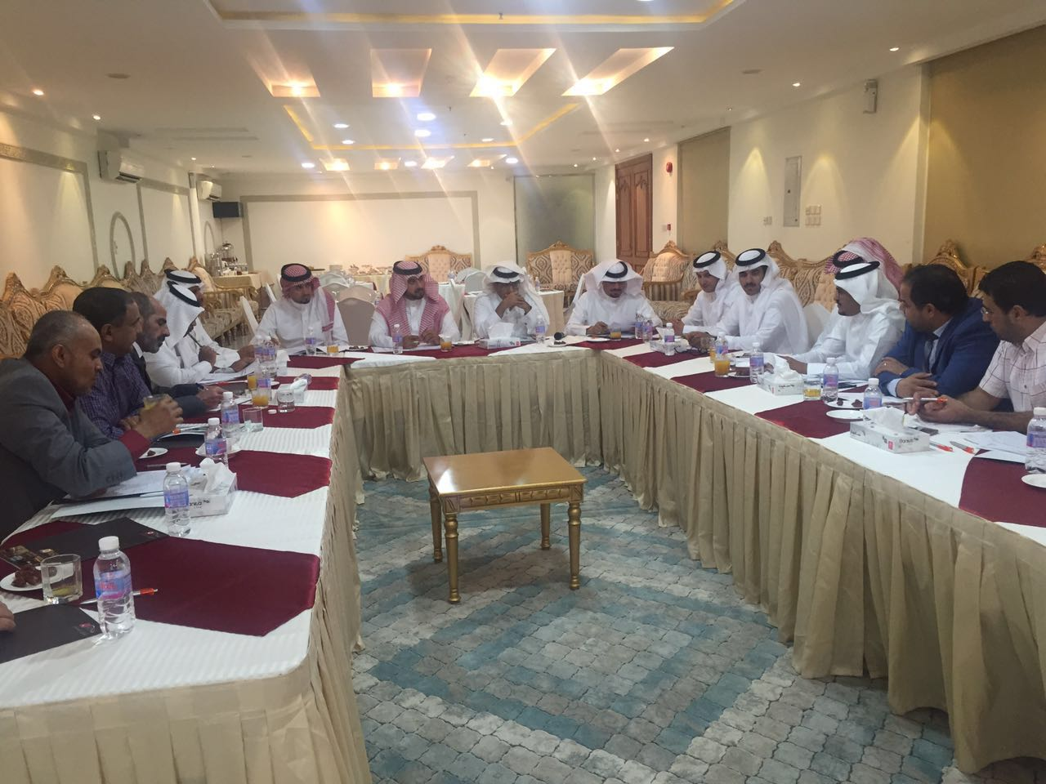
EE
Advisory Council
No. | Advisory Council Members
1. | Professor Abdullah Alwadie  Dean, College of Engineering  Najran University  Najran, Saudi Arabia  Tel: 00966 507776986  Email: asalwadie@nu.edu.sa | 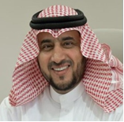
2. | Dr. Hisham Alghamdi  Vice Dean, College of Engineering  Najran University  Najran, Saudi Arabia  Tel: 00966 503790889  Email: haalghamdi@nu.edu.sa

3. | Engineer Saleh G. AlGhamdi  Director of SEC-Najran  Najran, Saudi Arabia  Tel: 00966 530588559  Email: saLdaghish@se.com.sa | 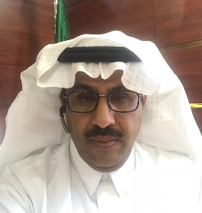
4. | Engineer Fawaz Masoud Alhadi  Najran College of Technology  Head of Electrical Technology Department  Najran, Saudi Arabia  Tel: 00966 503724374  Email: falhadi@tvtc.gov.sa
5. | Engineer Al-Hassan Muhi Al-Mutair  Saudi Electrical Company  Transmission Engineer  Najran, Saudi Arabia  Tel: 00966 533008835  Email: hmmutair@se.com.sa
6. | Assist. Prof. Dr. Adam Alhawri  Electrical Engineering Department  College of Engineering  11001 Najran, Saudi Arabia  Email: aralhawari@nu.edu.sa  Tel: 00966 541081747 | 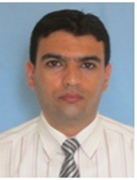
7. | Assist. Prof. Dr. Abdulkareem Al-Mawgani  Electrical Engineering Department  College of Engineering  11001 Najran, Saudi Arabia  Email: ahalmawgani@nu.edu.sa  Tel: 00966 534607367
8. | Engineer Al-Hassan Manea Al-Zamanan  Saudi Electrical Company  Distribution Engineer  Najran, Saudi Arabia  Tel: 00966 544774407  Email: HMzamananz@se.com.sa
Engineer Al-Hassan Manea Al-Zamanan
Saudi Electrical Company
Distribution Engineer
Najran, Saudi Arabia
Tel: 00966 544774407
Email: HMzamananz@se.com.sa

